**LAIKIPIA UNIVERSITY ONLINE CONTRACT MANAGEMENT SYSTEM**

|  |  |
| --- | --- |
| **Student Name** | **Registration Number** |
| John Maina Macharia | N11/30412/13 |

A software project submitted in partial fulfillment for the requirement by Bachelor of Science Computer Science of Laikipia University.

MAY, 2016

# **DECLARATION**

This software project is my original work, except where otherwise stated and has not been presented for a degree in any other University or any other award.

………………………………. ………………………

John maina Date:

# **CERTIFICATION**

The undersigned certify that he has read and hereby recommend for acceptance of Laikipia University a software project entitled “Laikipia University Online Contract management System”.

………………………………. ………………………

Dr. Simon M. Karume Date:

Department of Computer Science and IT

Laikipia University

# **COPYRIGHT**

This software project is copyright material of Laikipia University. It may not be reproduced by any means in full or in part without acknowledgement or written permission of the Dean School of Science and Applied Technology on behalf of both the author and Laikipia University.

# **DEDICATION**

This project is dedicated to the Laikipia University procurement Staffs for their support for the resources and information required for this project development. I dedicate it to Dr. Karume Computer Science Lecturer, Laikipia University, for his technical guidance in the project and motivation towards the project development. Without forgetting family and friends who also provided the motivation, financial and moral support.

# **ACKNOWLEDGEMENT**

I would like to express my greatest gratitude to my project instructor, Dr. Karume for his guidance in the project development. Special thanks to the Laikipia University Procurement Department for technical support.

# **ABSTRACT**

Procurement office offers contracting services like advertising contracts, selecting contractors, offering contract form and acceptance form. The aim of this project is to design an online contracting system that will offer services offered by contract management department online to help in solving some of the problems related to the current existing manual process of contracting by making it more convenient, fast, and transparent and an economical process. The proposed Laikipia University Online Contract Management System will be able to register interested contractors, administrator and contract officials online. It will offer contractor and acceptance form online to the contractors thus contractors does not have to visit the Institution to collect those forms. Verification of qualified and applied contractors will be done by the contract officials online by selecting them and submitting their choices to the database. Before expiration dates of the contract forms, contractors will be able to apply the contracts and submit for the verification. The contractors can then check if they have qualified for the post of contracting. The methods used to gather the requirements for the system included, interviews, research of publications and online materials. The scope of the system is to work within suppliers and procurement official. The system development process is scheduled to be implemented within six months; from 12th October 2015 up to 23rd March 2016. The system is to be developed using interactive web development tools such as: PHP, HTML, CSS, JAVA Script, JQuery and MySQL databases.

**Table of Contents**

**DECLARATION** ii

**CERTIFICATION** iii

**COPYRIGHT** iv

**DEDICATION** v

**ACKNOWLEDGEMENT** vi

**ABSTRACT** vii

**List of Tables** x

**List of Figures** xi

**CHAPTER ONE** 1

**INTRODUCTION** 1

**1.0** **Background Information** 1

**1.1** **Project purpose** 1

**1.2** **Beneficiaries** 1

**1.3** **Problem Statement** 2

**1.4** **Description of the current system** 3

**1.4.1** **How the current system works** 3

**1.4.2** **Weakness of the current system** 3

**1.5** **Proposed solution** 4

**1.5.1** **Justification** 4

**1.5.2** **Objectives** 5

**1.6** **Feasibility study** 7

**1.6.1** **Net present value** 7

**1.6.2** **Return on Investment (ROI)** 7

**1.6.3** **Assumptions** 8

**1.6.4** **Issues for the user to consider** 8

**1.7** **Project schedule** 9

**1.8** **Project budget** 10

**CHAPTER TWO** 11

**LITERATURE REVIEW** 11

**2.0 Introduction** 11

**CHAPTER THREE** 14

**METHODOLOGY** 14

**3.0 Introduction** 14

**3.1 Software process models adopted** 14

**3.1.1 Strength** 14

**3.1.2 Weaknesses** 14

**3.2 Requirement gathering tools** 14

**3.3 System requirements** 15

**3.3.1 Hardware requirements** 15

**3.3.2 Software requirements** 15

**CHAPTER Four** 16

**SYSTEM ANALYSIS AND DESIGN** 16

**4.1** **Introduction** 16

**4.2** **Architecture design** 16

**4.3** **System analysis** 18

4.3.1 **Context diagram** 18

**4.3.2** **Domain analysis** 18

**4.3.3** **Use case models** 20

**4.3.4** **Entity relationship diagram and class diagram** 24

**4.3.5** **Sequence diagrams** 26

**4.4** **Database design** 29

**CHAPTER FIVE** 30

**SYSTEM IMPLEMENTATION AND TESTING** 30

**5.1 Introduction** 30

**5.2** **Summary of modules** 30

**4.3.6** **Administrator Module** 31

**5.2.2** **Contractor module** 31

**5.2.3** **Financial Officer Module.** 31

**5.2.4** **Official Staffs Module.** 32

**5.3** **Summary of how the system works** 32

**5.3.1** **Home Page** 33

**5.3.2** **Contractor Module** 33

**5.3.3** **Finance Officer module** 34

**5.3.4** **Administrator Panel** 35

**5.4** **Test Regime** 36

**5.5** **Conclusion** 36

**5.6** **Recommendation** 37

**References** 38

**APPENDICES** 38

**Appendix 1: Questionnaire** 38

**Appendix 2: Source codes** 44

**Appendix 3: Test data** 64

# **List of Tables**

Table 1: Objectives (user research**)** 6

Table 2: Project Schedule (user research) 9

Table 3: Project Budget (user research) 10

Table 4: Class diagram (Author) 25

Table 5: Database Design (Author) 29

Table 6: Test regime (Author) 36

# **List of Figures**

*Figure 1:system Architecture (Author)* 17

*Figure 2: Context diagram (Author)* 19

Figure 3: Administrator use case (Author) 21

Figure 4: Contractor use case (Author) 22

Figure 5: Finance Officer use case (Author) 24

Figure 6: Official Staffs use case (Author) 24

Figure 7: Entity relationship diagram (Author) 26

Figure 8: Contractor sequence diagram (Author) 28

Figure 9: Administrator sequence diagram (Author) 29

Figure 10: Finance Officer Sequence diagram (Author) 30

Figure 11: Official Staffs Sequence diagram (Author) 31

Figure 12: home page (user) 36

Figure 13: Contractor Module (user) 37

Figure 14: Financer Officer Module (user) 38

Figure 15: Administrator Panel (user) 39

# **CHAPTER ONE**

# **INTRODUCTION**

## **Background Information**

Procurement Office at Laikipia University is essential in advertising contracts, assigning and selecting contractors to carry out advertised jobs. Procurement staffs are guided by the principle of fairness, transparency and integrity. Procurement methods vary depending on the estimated value and the nature of goods and services being procured. These procurements methods are open competitive, bidding, limited tendering, shopping and direct or sole source contracting. Where sole source contracting is used, procurement notices are advertised through relevant publications. Interested contractors may go to Institutional procurement notices for ongoing and future open competitive bidding exercises for the year. Contractors are able to apply for contracting services. Laikipia University uses the manual way of contracting where the contractor comes to the Institution, get the contract form, apply and if qualified offered with acceptance form where he/she can start applying.

## **Project purpose**

The following are the purpose that the proposed system is determined to achieve:

1. To streamline administrative tasks and reduce overhead by providing a single, unified view of each contract’s processes.
2. To make financial processes more efficient.

## **Beneficiaries**

The people benefiting from the proposed system will include the following:

1. Contractors – Due to services offered online it will reduce cost and save time to contractors.
2. Institution – Due to wide market that promote competition in contracting, this will stabilize prices of goods required by Institution. Also it saves cost by avoiding paper work.
3. Contracting Staffs – Providing services online it saves time to staffs by reducing retrieval of paper works and attending to contractors.

## **Problem Statement**

The procurement Office of Laikipia University has been using manual way of contract where Procurement office advertises its contracts at newspapers or relevant resources where the contractors after getting information visit the Institution, collects contract form and apply for post of contracting, procurement Officials select qualified contractors and offer the acceptance forms to those contractors, this is cost expensive and time consuming since the contractors need to travel and get contract papers and acceptance form.

Due to limited area coverage of the news about procurement adverts, the contractors have less access to information about the Institution and their contracts, this encourage few competitors in contracting services.

During selection of qualified contractors using manual way of procurement, the procurement officers in charge of selecting those contractors can accept bribes to some contractors thus increasing the rate of corruption in the institution.

## **Description of the current system**

### **How the current system works**

Laikipia University uses the manual way of contracting where the procurement department advertises the contracts to the newspaper or at university’s billboards where interested contractors after getting the news about the contract visit the institution to collect the Contract Forms to fill, reads the policy binding the contracting in the institution and then forward them to procurement officials for selection of qualified contractors. The contractors who have qualified for the post of contracting at specifics contracts are then informed through newspaper advertisement and address contacts. The contractors then visit the Institution again to collect acceptance form.

The contractor start his/her project until he finishes after being offered a contracting work. During this process the procurement office sends a representative to track the progress of the contract performed and the payments are made to the contractor accordingly. The contractor must keep all the records of his/her progress which he/she can use to request for the fund from the procurement office.

### **Weakness of the current system**

Slow cycle time is one of the enemy of contract efficiency. It begins with how simple or difficult is to request a new contract, get it into the queue and route it to the right people with all the required information. Slow cycle times can push revenue into the next quarter and make a procurement a roadblock.

New contracts don’t use the latest and approved language, which makes it difficult to enforce standards without costly and time consuming legal review.

Complex highly negotiated contracts frequently require multiple approvals from different functions in an organization. Usually the more complex approvals become the longer they take.

Compared to negotiation and approvals, execution should be very simple. Yet incomplete approvals and missing signatures often delay this basically straightforward step.

## **Proposed solution**

### **Justification**

The proposed Laikipia University Online Contract Management System will perform work of a contracting by offering contract and acceptance form online and performing selection of qualified contractors online, this would saves time to both the Institution and the contractors.

The proposed Laikipia University Contract management System will integrate seamlessly with an Organisation’s lines of business systems. This makes it easy for anyone in an organization to initiate contracts from within familiar applicartions and search for contract related information they require, eliminating system access as a process bottleneck.

Contractors will be able to access more information about the institution and their contracts, this would be by accessing advisory document about e-contracting and news on contracts.

The system will improve large competitors due to large area coverage of the online advertisement and more access to information online.

### **Objectives**

The following are the general and specific objectives of the system.

|  |  |
| --- | --- |
| **GENERAL OBJECTIVE** | **SPECIFIC OBJECTIVE** |
| 1. Provide security of user details submitted online. | * Enable administrator to register online * Enable admin to login * Enable contractor to register online * Enable contractor to login * Provide registration form to procurement officials online * Enable procurement Officials to login |
| 1. Improve information access | * Providing advisory document about contracting management online * Enable contractors to view list of bidders online. * Enable contractors to view latest tenders and cancelled tenders online. * Enable contractors to view policy and instruction of the procurement office pertaining supplying of the goods online. * Enable contractors to view invitation information about contracts. |
| 1. Saves time and cost by enabling suppliers to obtain tender and order form online | * Provide contract form online to contractors. * Provide acceptance form to qualified contractors online where qualified contractors can download them. * Enable finance office to track and view the progress of contractor through viewing of updated progress by contractors. |
| 1. Offer efficient and affordable administrative work among the official and administrator | * Enable admin to add, edit and remove post of contracts online. * Enable admin to add Invitation information online. * Enable finance officer to view contractor details online. * Enable the finance office to compute the payment of contractor online. * Enable procurement officials to view applied contractors online. |
| 1. Reduce corruption and bribery in procurement offices. | * Enable procurement officials to select qualified contractors online. |

Table 1: Objectives (user research**)**

## **Feasibility study**

This is a feasibility study on the proposed Laikipia University Online Contract management System. This study aims to prove or disapprove the financial prudence of creating and implementing the said system. The proposed system will be responsible for handling outsourced development contracts. The key advantage of the proposed system is reduction or elimination of manual labour and paper work required for the monitoring of contracts which are all prone to human errors.

### **Net present value**

The net present value compares the future returns on a given investment to the cost that will be incurred investing in the project. In this case the returns will be the savings made by reducing the salary and benefits that would be due to the redeployed employees.

The present value in this case is comparing the total savings adjusted to the 8% discount rate to the Development cost that would be involved in developing the system. This is a positive net present value of over 2 million ksh. This means that it would be a good financial investment to replace the outsourced labor to develop the system.

### **Return on Investment (ROI)**

The ROI will calculate the percentage return on an investment. The formula for calculating ROI is (return – investment/investment*100).

The ROI is 291.6% which is more than enough to justify outsourcing programming services to develop the system. The NPV also recommends the development of the system as it is positive.

### **Assumptions**

The expenditure used to calculate the NPV and the Return on Investment has not put into place the fees in training the workers of the new system.

The feasibility has assumed that there are no legal fees to be incurred in case of a contractual breach.

The discounting figure (8%) has been used assumed to be constant throughout the period under consideration.

In calculating the costs and benefits of the redeployed employees, the effects of inflation have not been factored.

### **Issues for the user to consider**

The following are the consideration to be looked at:

1. Will the redeployed employee’s seed legal readdress for perceived unlawful termination?
2. Who are the persons who will be authorized to access the data recorded and stored on the new system?
3. Will the Institution’s already existing hardware be able to handle the running of the new system?
4. Are there better system development methodologies that will ensure the success of the contract management system?

## **Project schedule**

|  |  |  |  |  |
| --- | --- | --- | --- | --- |
| TASK NO: | TASK DESCRIPTION | STARTING DATE | END DATE | %COMPLETION |
| 1 | Concept and proposal writing | 5th October 2015 | 12th October 2015 | Done |
| 2 | Defence of the proposal | 12th October  2015 | 19th October  2015 | Done |
| 3 | Requirement analysis | 2nd january 2016 | 20th January 2016 | Done |
| 4 | System analysis and design | 20th January 2016 | 10th February 2016 | Done |
| 5 | System implementation | 2nd January 2016 | 13th April 2016 | Done |
| 6 | System testing | 13th April 2016 | 17th May 2016 | Done |
| 7 | Documentation | 5th Octomber 2015 | 18th May 2016 | Done |
| 8 | Printing and binding | 25th May 2016 | 26th May 2016 | Done |

Table 2: Project Schedule (user research)

## **Project budget**

|  |  |
| --- | --- |
| EXPENSE | COST( KSH) |
| Online research(internet bundles) | 500.00 |
| Software purchase | 1500.00 |
| Printing and photocopy | 2000.00 |
| Miscellaneous | 1000.00 |
| Bidding | 4000.00 |
| Total | 9000.00 |

Table 3: Project Budget (user research)

# **CHAPTER TWO**

# **LITERATURE REVIEW**

## **2.0 Introduction**

This chapter presents the comparison and review of previous literature of the system and the proposed Laikipia University Online Contract System. It review an online Government procurement system called IFMIS (INTERGRATED FINANCIAL MANAGEMENT INFORMATION SYSTEM). IFMIS is a government automated system enhances efficiency in planning, budgeting, procurement, expenditure management and reporting in the national and county Governments in Kenya (Wamwangi, July) Some of ideas covered in IFMIS are:

1. Cost effectiveness.

It ensures that cost is reduced by making all services to be obtained online like contracts and acceptance form. This reduces cost to both the Organization and the Contractors. Contracts and acceptance form are offered online thus this help in enabling the contractors to incur no cost of travelling and other expenses of coming to take the forms manually. (Wamwangi, July) Also in the side of the organization, all the paper work that require printing costs of this forms are eliminated.

1. Integrity of contracting process

Offers registration to contractors and security in submitting details of the contractors. All the details submitted are secured and stored to the secured database. All the information cannot be tampered with incase of corruption and hence improves integrity of the system (Kakame, 2013)..

1. Time convenience

Through obtaining services online, contractors are able to save their time without travelling. Since all the services are offered online, this services are obtained faster and the time of obtaining this services is minimized. (Wamwangi, July)

1. Effectiveness and improved outcomes are important goals for any IFMIS acquisition.

The objective of IFMIS is to increase the effectiveness and efficiency of state financial management and facilitate the adoption of modern public expenditure management practices in keeping with international standards and benchmarks (James, 2012).

Things that the proposed system will address which have not been addressed by the IFMIS.

1. Training staffs on how to use the system efficiently without making errors

Chairman Benson Okundi suggest that IFMIS is just a system, if someone feeds erroneous information, it will generate erroneous information (Kakame, 2013). Mr Tom Kakame, a treasury official who appeared before the committee said tht there has been problems in training officials on how to use the system. The proposed system will contain understandable online document which officials can download and read them on their free time thus making them familiarize with the system.

1. Confidence creation to contractors

Contractors need to be sure that the system is not corrupt and that their choices are selected well and those who have qualified for the post of contracting are chosen without corruption. The proposed system will enable contractors to view the applied contractors and qualified contractors thus if one has not applied and he/she is on the list they can know.

1. Improve knowhow about e-contracting

Offering advisory document about e-procurement and best bidding advices beside the details about the system, the contractors can be able to know more about e-contracting. Due to limited know how about online contracting the proposed system will enable contractors to view and read documents about online contracting to make them have confidence on all processes carried on to the feedback results displayed to them by the system. It also help guide the user on various method of gaining competitive advantage against the other with the help of this online document.

# **CHAPTER THREE**

# **METHODOLOGY**

## **3.0 Introduction**

In this chapter data collection methodologies, software process models adopted, software and hardware requirements are stated.

## **3.1 Software process models adopted**

This project uses iterative development lifecycle, where components of the application are developed through a series of hard iteration.

### **3.1.1 Strength**

The choice of the iterative method of development is to ensure the Laikipia University Procurement Management is improved step by step. I was interested in searching system defects at early stage and therefore pick on the iterative process model.

### **3.1.2 Weaknesses**

The weakness of the software process model is that there is costly architecture and design issues may arise because not all requirements are gathered up for the entire lifecycle.

## **3.2 Requirement gathering tools**

Interviews of the departmental representatives

I carried out interviews at Laikipia University Procurement office where I interviewed procurement officials and reviewed Procurement procedures, policies and processes of acquiring tender form up to being issued with an order form to start supplying.

## **3.3 System requirements**

### **3.3.1 Hardware requirements**

1. Any processor speed for Intel, AMD, Celeron processors
2. 512 Megabytes RAM.
3. 30 Gigabyte hard drive.
4. VGA color monitor (256 color capability and 1024 x 768 Resolution; 4MB Video RAM).
5. Networked access to the server containing the Multi-Access database, 32 bit network adapter card/PCI
6. Net Card.

### **3.3.2 Software requirements**

1. Operating System: Windows XP, Windows Vista or Windows OS.
2. Database: MySQL for the system database.
3. Technologies: PHP, HTML, CSS, J Query and AJax, java script.
4. IDE: Notepad ++, Zend Framework
5. Browser: Firefox 35.0.

# 

# **SYSTEM ANALYSIS AND DESIGN**

## **Introduction**

This chapter presents the system analysis and design process .This software design document provides a vivid description of the technical design for the Laikipia University Online Contract management System. The goal is to fully describe the technical view for how the system and business requirements will be realized. This document provides an architectural overview of the system to depict different aspects that the system covers. This document also functions as the fundamental reference point for developers involved with the system development.

## **Architecture design**

For this system we have chosen the client server model which is characterized by two distinct interacting processes; the client and the server which in general can run on different computers, exchanging data over the network using protocols such as HTTP, HTTPS and TCP/IP etc. The design of online Contract management system consists of a clients who are contractor, finance officer, official staffs and administrator, webserver and database server. A registered contractor, finance officer and staffs and administrator connect to a webserver by using their login identification and password. The client and web server communicate by internet using protocols (Ell, 16th, April, 2015,). The relationship is illustrated in the diagram below

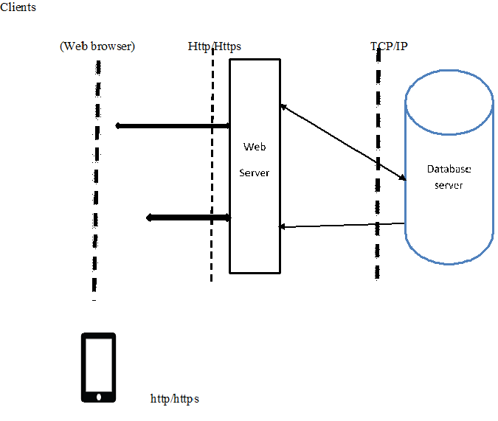

*Figure 1:system Architecture (Author)*

Clients and servers exchange messages in request-response messaging pattern: The client sends a request and the server returns a response. This exchange of messages is an example of an inter-process communication. To communicate the computers must have a common language, and they must follow rules so that both the client and the server know what to expect. The language and rules of communication are defined in communication protocol.

In this case, when a user accesses online contract services with a web browser (the client), the client initiates a request to the online contract server. The user’s login credentials is stored in a database and the webserver accesses the database server as a client. An application server interprets the returned data by applying the online contract procedures, and provides the output to the web server .The application server – through a database connector-handles all database requests from the clients’ side to the database.

## **System analysis**

### **Context diagram**

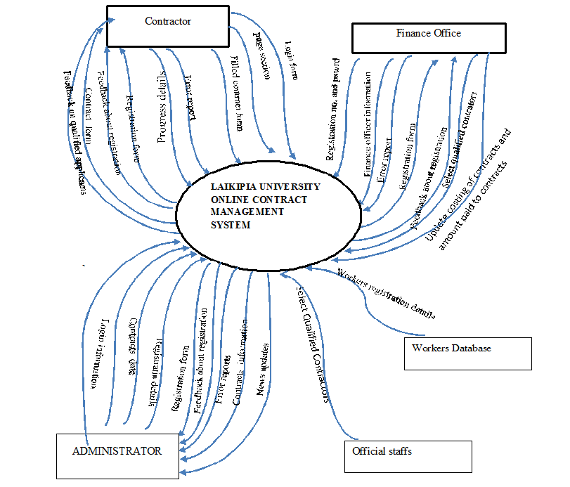

*Figure 2: Context diagram (Author)*

### **Domain analysis**

This software application is designed as an object-oriented system for an Internet-based architecture using three–layer architecture by factoring application classes into the following layers:

1. **The Presentation layer** - This is the layer where the physical window and widget objects live. It will also contain Controller classes as in classical MVC. Any new user interface widgets developed for this application are put in this layer.
2. **The Domain Mode**- Most objects identified in the OO analysis and design will reside. To a great extent, the objects in this layer can be application-independent. Generic objects may be used in this application to reap the benefits of Object Oriented programming.
3. **The Data layer** - The data is managed by MySQL.

The following entities were identified for the system

* Contractors
* Official staffs
* Finance officer
* Administrator
* System database
* Workers database
* contracts

The following use cases were identified:

* Contractor use case
* Finance Officer use case
* Administrator use case

### **Use case models**

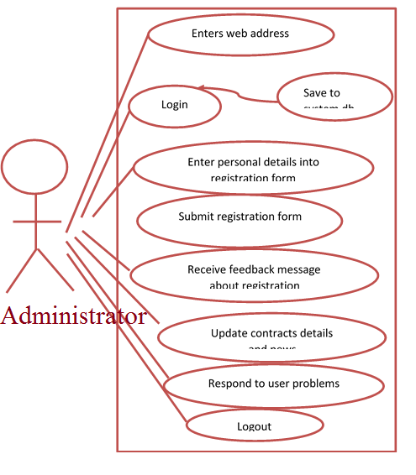

Figure 3: Administrator use case (Author)

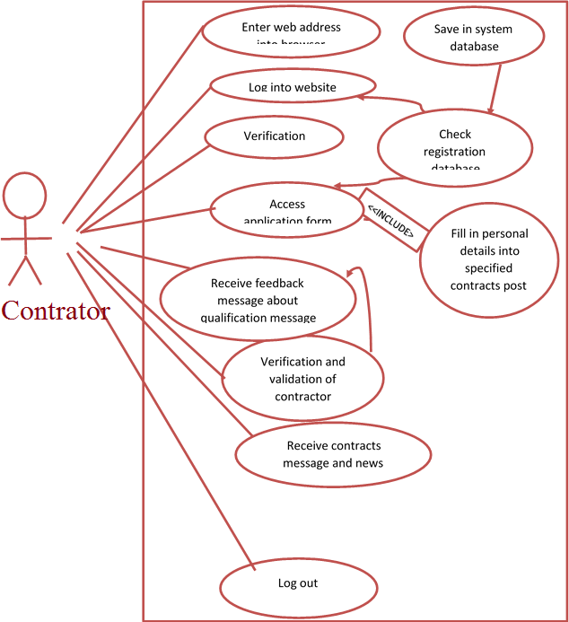

Figure 4: Contractor use case (Author)

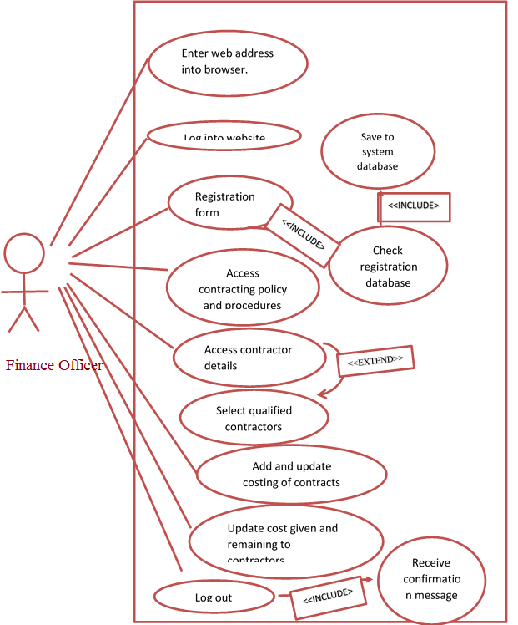

Figure 5: Finance Officer use case (Author)

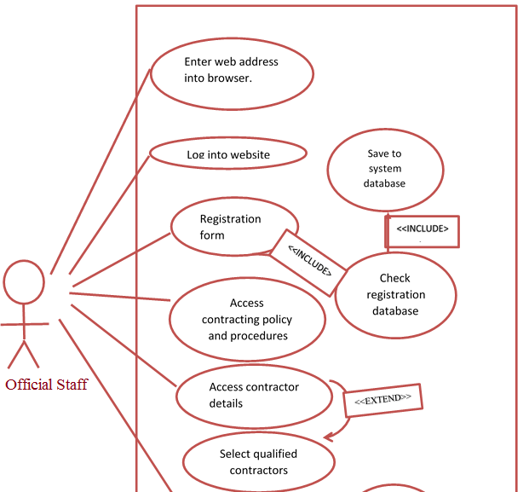

Figure 6: Official Staffs use case (Author)

### **Entity relationship diagram and class diagram**

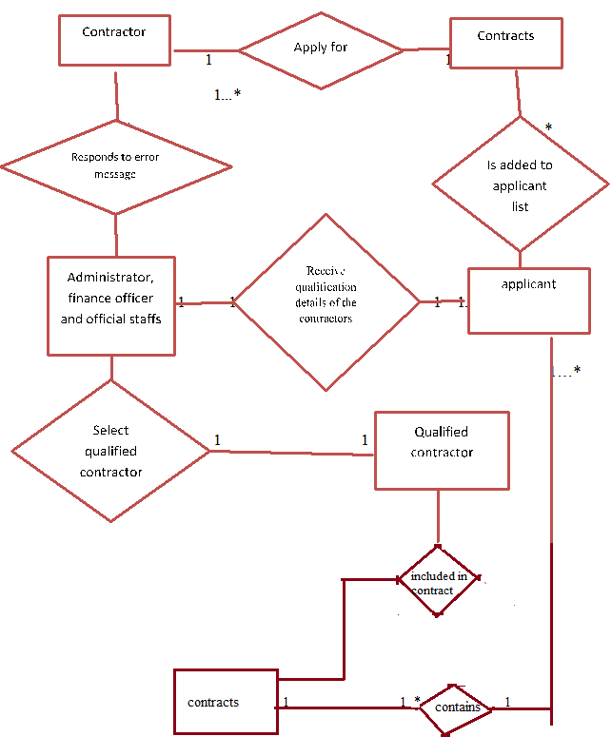

Figure 7: Entity relationship diagram (Author)



Table 4: Class diagram (Author)

### **Sequence diagrams**

#### **Contractor Module**

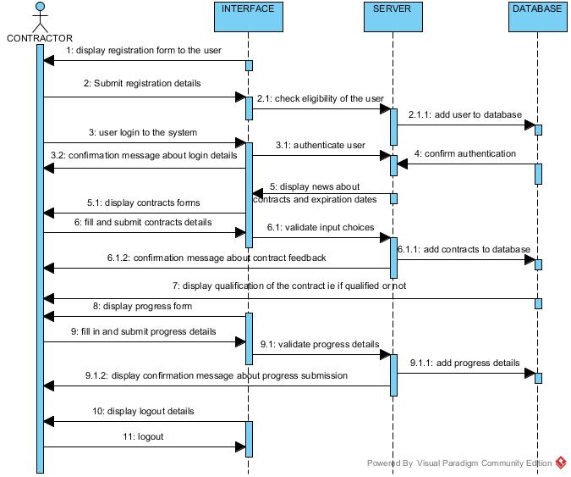

Figure 8: Contractor sequence diagram (Author)

#### **Administrator Module**

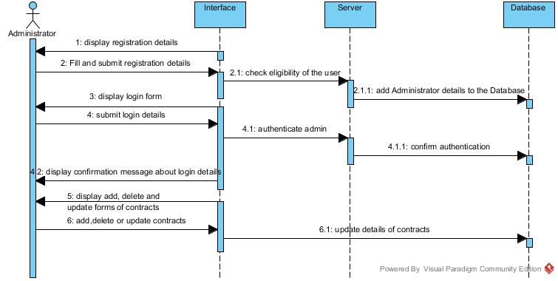

Figure 9: Administrator sequence diagram (Author)

#### **Finance Officer module**

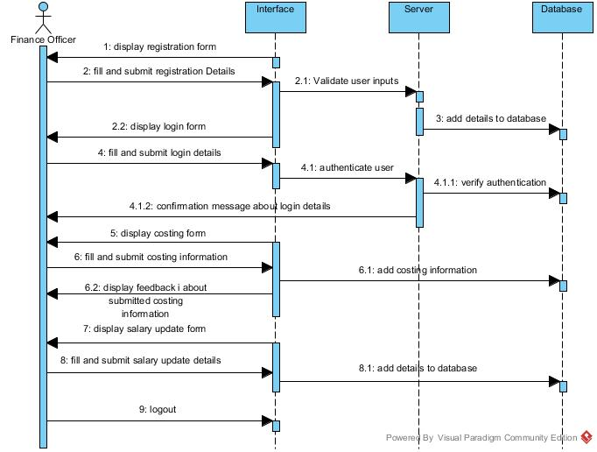

Figure 10: Finance Officer Sequence diagram (Author)

#### **Official Staffs module**

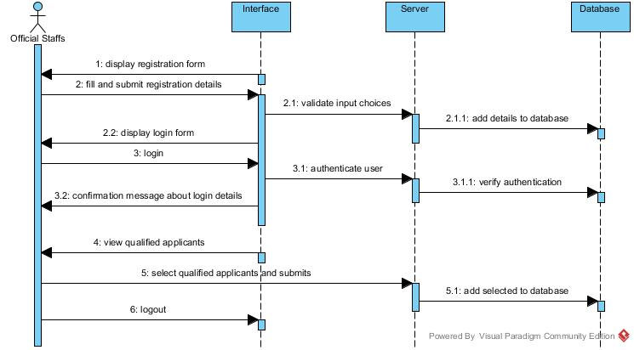

Figure 11: Official Staffs Sequence diagram (Author)

## **Database design**

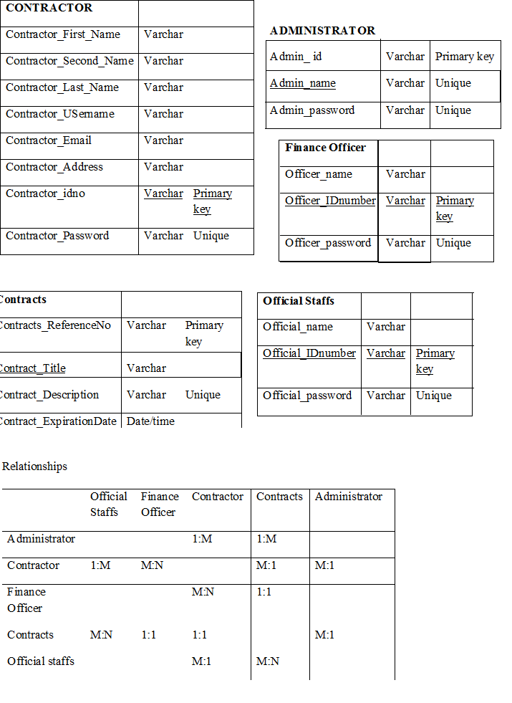

Table 5: Database Design (Author)

# **CHAPTER FIVE**

# **SYSTEM IMPLEMENTATION AND TESTING**

## **5.1 Introduction**

System implementation and testing are two vital phases which is concerned with implementing the system and testing it to identify bugs before releasing to the consumer/user. The logical and physical design is continuously examined to ensure that the test data are verified for correctness and accuracy. During testing two kind of errors are likely to occur: syntactic errors and logical errors. Syntactic errors occur when a program statement violates one or more rules of the language in which the programs are written in, this errors have to be corrected before the program is finally execute. The compilation of the program does not show any errors if the syntax errors are corrected. But when the system is run and the desired output does not appear this is due to logical errors. The errors can be corrected by commanding the program to display a number of message statements. Different modules would be tested individually and are made error free.

## **Summary of modules**

The main modules of Laikipia University Online Contract Management System are:

1. Administrator module
2. Contractor module
3. Finance officer module
4. Official staffs module.

### **Administrator Module**

This module provides the administrator with services of registration, login, adding new contracts, deleting contracts, adding and deleting online documents, selecting qualified applicant. The system administrator must first register by filling her details in the registration form. Her/his details are saved in the official table in the registration database. If registration is successful the administrator is provided with a login form. The admin has the privilege of viewing applicant contractors.

### **Contractor module**

This module is mainly concerned with the contractor where he/she first register, where he/she is provided with login form and he can then apply for the contracts. He/she waits for qualified news about himself/herself and if qualified he fill the agreement/contract form to come into agreement with the Institution. The contractor has ability to view if he/she is qualified or not, view contracts posts, view news posted about contracts.

### **Financial Officer Module.**

This module provides the financial officer with services of registration, login, adding costing details of the contracts, selecting qualified applicant. He/she must first register by filling her details in the registration form. Her/his details are saved in the official table in the registration database. If registration is successful the finance officer is provided with a login form. He/she has the privilege of viewing applicant contractors. He is also provide with online calculator for mathematical calculations if needs be.

### **Official Staffs Module.**

This module provides the staffs with services of registration, login, selecting qualified applicant and viewing applicant contractors. The staffs must first register by filling their details in the registration form. Her/his details are saved in the official table in the registration database. If registration is successful the staff is provided with a login form.

## **Summary of how the system works**

Laikipia university online Contract management system works in the following way: The first event is the registration of the administrator, he/she is presented by a registration form where he fills in his/her registration details according to the specifications in the form after successful registration he is provided with a platform to create his/her login account to allow him/her to access the system parts specified for him .The system administrator updates information about the contract details including dates and other news. Then the contractors access the site on the browser and he/she clicks on contractor’s panel where he/she can register or login. He/she enters his or her details into the form according to the fields specification in the form and clicks submit, the contractors details are authenticated and verified to see if he or she exists in the applicant database of the university if her records are present a message is sent back to him informing him that the registration is successful her/his details are saved in the system database as a contractor. He/she can then login and logout to his/her account using a username and a secret password, if the registration process is not successful a message is displayed informing him that he is already registered and he can proceed in signing in. the contractor can the add progress of his contract, delete finished ones and update any changes.

The official staffs have ability to select qualified applicant and view the applicant. The finance office enters the costing of contracts, the amount given to the contractor and then he/she can generate the remaining amount.

### **Home Page**

This is the home page where contractor, finance officer and administrator can perform their task by login in and viewing their pages.

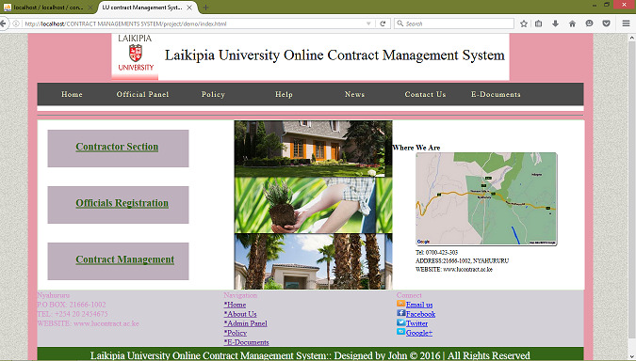

Figure 12: home page (user)

### **Contractor Module**

This is the contractor module. The contractor can fill contractor form, view if qualified, view acceptance form and edit his/her progress details.

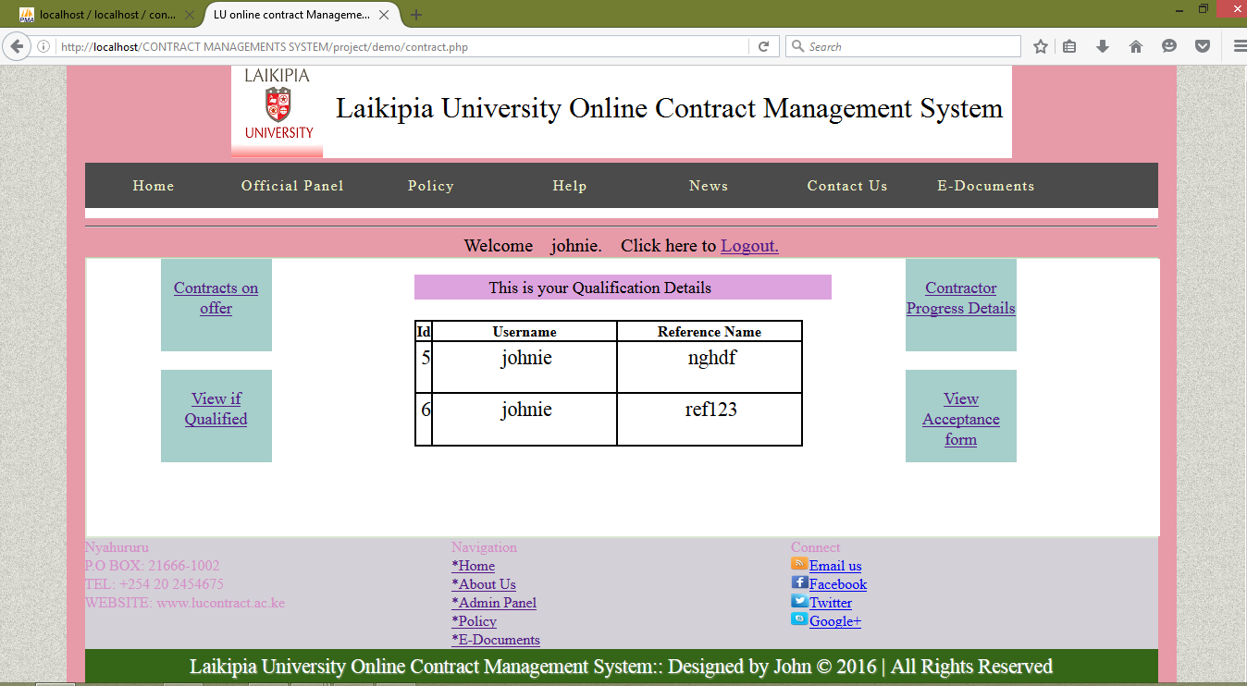

Figure 13: Contractor Module (user)

### **Finance Officer module**

This is a finance officer module where he/she can view contractors application details, select qualified contractors, use calculator for mathematical computation, generate given and remaining amount of money and update costing of contracts.

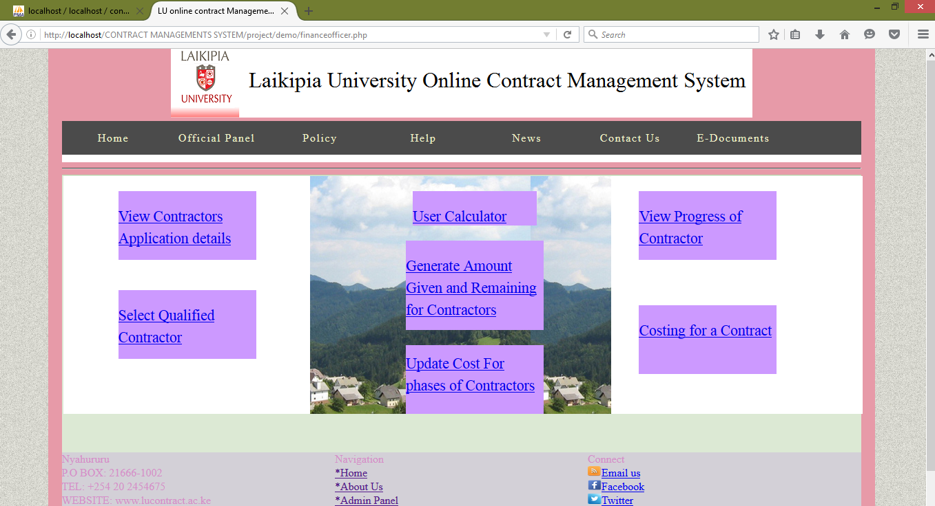

Figure 14: Financer Officer Module (user)

### **Administrator Panel**

The admin can do the following: add contracts, select qualified, view contract, add invitation, delete invitation, add online documents, delete contract and delete online document.

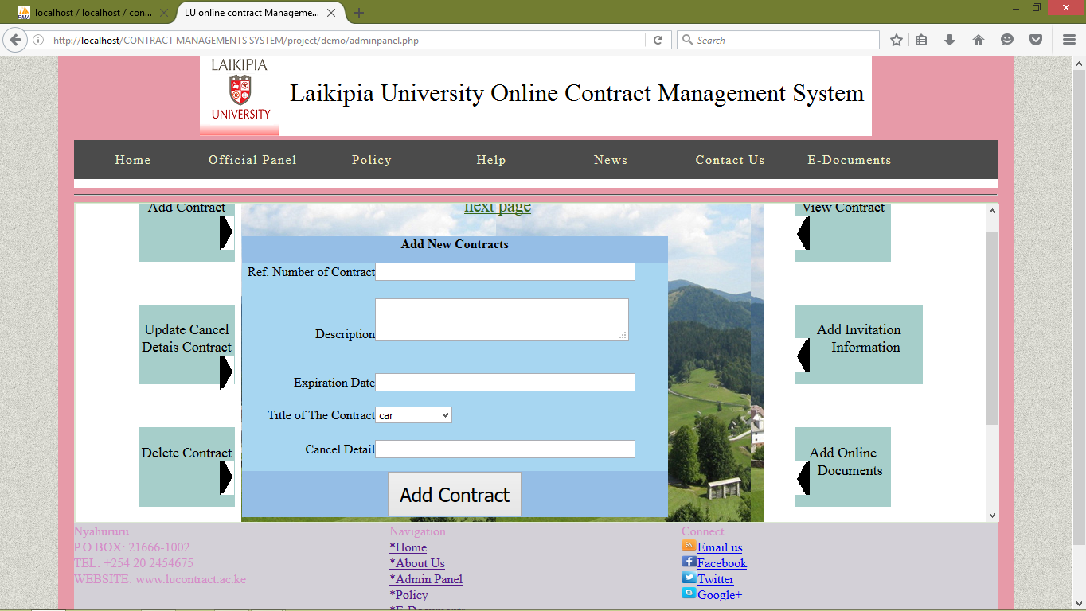

Figure 15: Administrator Panel (user)

## **Test Regime**

|  |  |  |  |  |
| --- | --- | --- | --- | --- |
| Test id | Description | Test data | Expected results | Actual results |
| 1 | Contractor registration |  | Registration successful. contractor records updated in contractor table in the registration database | Registration successful |
| 2 | Login |  | Allow access into the system | As expected |
| 3 | Administrator registration |  | Registration successful. admin records updated in official table in the registration database. | As expected |
| 4 | Official staffs registration |  | Registration successful. staffs records updated in official table in the registration database. | As expected |

Table 6: Test regime (Author)

## **Conclusion**

Some research has shown than online contract management systems can guarantee a credible and reliable contracting process. (I.J computer Networks and Information, 2013).This proposed LU online contract management system aims to polish the image of Laikipia University Contracting System by making it more integral and trustworthy .It is observed that a lot of problems and inconsistency that arise from manual contracting system can result into serious manipulation of contracts.

In conclusion careful planning and implementation of LU contract management system and careful engineering of the system hardware and software be achieved by adoption of this system.

## **Recommendation**

After a lot of research many challenges associated with the manual contracting system used in Laikipia University currently came to our attention but we are certain that these challenges could be solved if the online contract management system is adopted. We therefore recommend the following: There should be adoption of distributed encryption techniques for the purpose of secure data transmission, there should be adequate and proper user or public enlightenment on how to use the system, precautions to take when using the system and the benefits of using online contract management system before the system is implemented. We also recommend that more research should be carried out on this area to realize more improvements especially in areas such as voter authentication and database security that can be made on our proposed system. Finally we recommend that Laikipia University should take up this project as it will be greatly beneficial to the institution.

# **References**

Ell. (16th, April, 2015,). Client-Server model (n.d). *wikipedia.org.*, 6, 12, 15.

I.J computer Networks and Information. (2013). *computer Networks and Information.*

James. (2012). The public Finance management Act.

Kakame, T. (2013). Certified Public Accountants of Kenya. *Certified Public Accountants of Kenya*.

Wamwangi, K. (July). *Authority Transition.* Nairobi.

# **APPENDICES**

# **Appendix 1: Questionnaire**

Dear respondent.

I would wish to tackle one of the most vital activities in the university that involves contracting activities in the procurement office by computerizing the process by design a contracting system. The completion and success of the design of contracting system would be a success of my Project work as a computer science student. I would therefore ask to source information from you to enable us acquire enough requirements to aid in the design of a satisfactory system.

**Procurement Staffs:**

**Personal Details:**

1. Are you a staff of Laikipia University?

Yes

No

If yes, what position in procurement department do you work?

…………………………………………………………………………………………………………………………………………………

**Technological Details:**

1. Do you have an access to the internet?

Yes

No

If yes, how often?

Every day

Three times a week

Twice a week

Once a week

1. What gadget do you use to access the internet?

Mobile phones

Personal computer

Cyber computers

1. How reliable is the internet?

**System Details:**

1. Do you participate in contracting process in any way?

Yes

No

If no, explain why

………………………………………………………………………………………………………………………………………………………………………………………………………………………………………………………………………………………………

1. What kind of system do you use for contracting?

Manual system

Online system

If other please list

…………………………………………………………………………………………………………………………………………………………………

1. Please provide the rating of the system efficiency.

Excellent

Very good

Good

Poor

Very poor

1. Are there challenges you have experienced with the current contracting system?

Yes

No

If yes, please state some challenges that are faced.

………………………………………………………………………………………………………………………………………………………………………………………………………………………………………………………………………………………………………………………………………………………………………………………………………………………………………………………………………………………………

1. Suggest any improvement that you may wish to be implemented

………………………………………………………………………………………………………………………………………………………………………………………………………………………………………………………………………………………………

1. Would you prefer an online contracting system to be implemented in the procurement processes?

Yes

No

If no, explain

…………………………………………………………………………………………………………………………………………………………………………………………………………………………………………………………………………………………………………………………………….

1. Are you familiar with an online contracting system?

Yes

No

If yes, state example…………………………………………………………………….

1. What would you like to be included and improved with the online contracting system?

………………………………………………………………………………………………………………………………………………………………………………………………………………………………………………………………………………………………………………………………………………………………………………………………

(Thank you for your responses, support and cooperation)

**Office of finance**

1. Are you involved in the Laikipia University contracting process?

Yes

No

If yes, how?

.............................................................................................................................................................................................................................................................................................................................................................................................

Do you experience any difficulties with the exercise?

Yes

No

If yes, explain

................................................................................................................................................................................................................................................................................................................................................................................................................................................

Would you prefer an online contracting system for the Procurement office?

Yes

No

If no, why?

................................................................................................................................................................................................................................................................................................

1. What would you wish to be improved with the online contracting system?

................................................................................................................................................................................................................................................................................................

Thank you for your cooperation and support)

## **Appendix 2: Source codes**

**Code for admin panel**

<?php

session_start();

error_reporting(E_ERROR|E_PARSE);

?>

<!DOCTYPE html><!-- Website template by freewebsitetemplates.com -->

<html>

<head>

<meta charset="UTF-8">

<title>LU online contract Management System</title>

<link rel="stylesheet" type="text/css" href="css/style.css">

<link rel="stylesheet" type="text/css" href="css/style2.css">

<link rel="stylesheet" type="text/css" media="all" href="style.css">

<script type="text/javascript" src="jquery-2.1.4.js"></script>

<script type="text/javascript" charset="utf-8" src="js/jquery.leanModal.min.js"></script>

<style type="text/css"><!--

.style10 {font-family: "Times New Roman", Times, serif; font-size: 18px; }

--> </style>

<style>

.tableheader{background-color:#95BEE6; color:white; font-weight:bold;}

.tablerow{background-color:#A7D6F1; color:white;}

.message{color:FF0000; font-weight:bold; text-align:center; width:100%}

.style11 {color: #000000}

</style></head>

<body>

<div id="page">

<div id="heading">

<div id="topnav" style="text-align:center">

<img src="images/lulogo.png" alt="Image" />

</div> </div>

<div id="header" >

<ul><li><a href="index.html">Home</a></li>

<li><a href="">Official Panel</a><ul>

<li><a href="officialpanel.php">Official Staffs</a></li>

<li><a href="adminpanel.php">Admin panel</a></li>

<li>

<a href="financeofficer.php">Finance Officer panel</a>

</li>

</ul>

</li>

<li>

<a href="policy.html">Policy</a>

</li>

<li>

<a href="help.html">Help</a>

</li>

<li>

<a href="news.php">News</a>

<ul>

<li>

<a href="article.php">Breaking</a>

</li>

</ul>

</li>

<li>

<a href="contact.html">Contact Us</a>

</li>

<li>

<a href="doc.html">E-Documents</a>

</li>

</li>

</ul>

</div>

<hr style="red 2px"/>

<div id="secnav">

<div id="employees" style="height: 400px; overflow: auto;">

<table width="100%" height="300" border="2px" cellpadding="5" cellspacing="4" bordercolor="#000000" bordercolorlight="#666666" bordercolordark="#666666" bgcolor="#FFFFFF" frame="border" rules="cols">

<tr>

<br /><br /><br /><br /><br /><br />

<td width="209" height="288">

<blockquote class="style11"><blockquote>

<div align="center" style="width: 120px; border:#000000 2px double solid; height: 100px; background-color:#A6CECA; padding-top:20px; ">

<span class="style10"><br />Add Contract </span><br />

<br />

<a href="adminpanel.php" onclick=show()><img src="images/rexpand.PNG" style="margin-left:100px"></a> </div>

<p>&nbsp;</p>

</blockquote>

</blockquote>

<blockquote class="style11"><blockquote>

<div align="center" style="width: 120px; border:#000000 2px double solid; height: 100px; background-color:#A6CECA; padding-top:20px; ">

<span class="style10">Update Cancel Detais Contract </span><a href="cancelcontract.php" onclick=show()><img src="images/rexpand.PNG" style="margin-left:100px"></a></div>

</blockquote>

</blockquote>

<p class="style11">&nbsp;</p>

<blockquote class="style11"><blockquote>

<div align="center" style="width: 120px; border:#000000 2px double solid; height: 100px; background-color:#A6CECA; padding-top:20px; ">

<span class="style10"><br />

Delete Contract<a href="deletecontract.php" onclick=show()><img src="images/rexpand.PNG" style="margin-left:100px"></a> </span><br />

<br />

</div></blockquote>

</blockquote>

<p>&nbsp;</p>

<blockquote class="style11"><blockquote>

<div align="center" style="width: 120px; border:#000000 2px double solid; height: 100px; background-color:#A6CECA; padding-top:20px; ">

<span class="style10"><br />

Delete Invitation<a href="deleteinvitation.php" onclick=show()><img src="images/rexpand.PNG" style="margin-left:100px"></a> </span><br />

<br />

</div></blockquote>

</blockquote></td>

<td width="656" rowspan="2" align="center" valign="middle" style="background-image: url(images/Flowers_Nature_Landscape.jpg); cursor:auto; richness:inherit"><br />

<form action="" method="POST">

<table width="535" height="260" border="0" cellpadding="10" cellspacing="1" style="margin-left:-120px;">

<tr class="tableheader">

<td height="33" colspan="2" align="center" class="style11"><span class="style11">Add New Contracts </span></td>

</tr>

<tr class="tablerow">

<td width="154" height="43" align="right" class="style11"><span class="style11">Ref. Number of Contract</span> </td>

<td width="338" class="style11"><input name="refname" type="text" size="50" maxlength="50" required></td></tr>

<tr class="tablerow">

<td height="59" align="right" class="style11"><span class="style11">Description</span></td>

<td class="style11"><br />

<textarea name="description" cols="37" required></textarea></td></tr>

<tr class="tablerow">

<td height="41" align="right" class="style11"><span class="style11">Expiration Date</span> </td>

<td class="style11"><input name="expdate" type="text" id="text" size="50" maxlength="50" required></td></tr>

<tr class="tablerow">

<td height="41" align="right" class="style11"><span class="style11">Title of The Contract</span> </td>

<td class="style11"> <select name="title" required>

<option>car</option>

<option>land</option>

<option>rent</option>

<option>event</option>

<option>employment</option>

<option>services</option>

<option>construction</option>

</select>

</td></tr>

<tr class="tablerow">

<td height="38" align="right" class="style11"><span class="style11">Cancel Detail</span></td>

<td class="style11"><input name="cdetails" type="text" size="50" maxlength="50" required></td></tr>

<tr class="tableheader"><td height="39" colspan="2" align="center" class="style11"><input name="submit" type="submit" value="Add Contract" style="font-size:24px; padding:10px 10px; "></td>

</tr>

</table></form>

<span class="style11"></span>

<?php

//define the variables

$dbhost = "localhost";

$dbname = "contractmng";

$dbuser = "root";

$dbpass = "";

$refname=$_POST['refname'];

$Description=$_POST['description'];

$expirationdate=$_POST['expdate'];

$details=$_POST['cdetails'];

$tit=$_POST['title'];

//check if already confirm registration

try{

$con = new PDO("mysql:host=$dbhost;dbname=$dbname", $dbuser, $dbpass);

$count=$con->prepare("SELECT refname FROM contracts WHERE refname=:refname");

$count->bindParam(":refname",$refname);

$count->execute();

$no=$count->rowCount();

if($no==0 )

{

$sql="INSERT INTO contracts(refname, description, expdate, cdetails, title) VALUES(:refname, :description, :expdate, :cdetails, :title)";

$query=$con->prepare($sql);

$query->execute(array(':refname'=>$refname, ':description'=>$Description, ':expdate'=>$expirationdate, ':cdetails'=>$details, ':title'=>$tit));

if(isset($_POST['submit']))

{

echo'<script type="text/javascript">

window.alert("You have successfully added the contract!")

</script>';

}

}

else

{

echo'<script type="text/javascript">

window.alert("The contract already exist in our database!");

</script>';

}

}

catch(PDOException $e)

{

die('Could not connect to the database:' . $e);

}

?></td> <td width="279" > <blockquote class="style11">

<div align="center" style="width: 120px; border:#000000 2px double solid; height: 100px; background-color:#A6CECA; padding-top:20px; ">

<span class="style10"><br />View Contract<a href="viewcontract.php" onclick=show()><img src="images/lexpand.PNG" style="float:left;" ></a> </span><br />

<br />

</div></blockquote>

<p class="style11">&nbsp;</p>

<blockquote class="style11">

<div align="center" style="width: 160px; border:#000000 2px double solid; height: 100px; background-color:#A6CECA; padding-top:20px; "><span class="style10"><br />

Add Invitation Information<a href="invitation.php" onclick=show()><img src="images/lexpand.PNG" style="float:left;" ></a> </span><br />

<br />

</div>

</blockquote>

<p class="style11">&nbsp;</p>

<blockquote class="style11">

<div align="center" style="width: 120px; border:#000000 2px double solid; height: 100px; background-color:#A6CECA; padding-top:20px; ">

<span class="style10">Add Online Documents<a href="E_doc.php" onclick=show()><img src="images/lexpand.PNG" style="float:left;" ></a> </span><br />

<br />

</div></blockquote>

<p>&nbsp;</p>

<blockquote class="style11">

<div align="center" style="width: 120px; border:#000000 2px double solid; height: 100px; background-color:#A6CECA; padding-top:20px; ">

<span class="style10">Delete Online Documents<a href="deletedoc.php" onclick=show()><img src="images/lexpand.PNG" style="float:left;" ></a> </span><br />

<br />

</div></blockquote> </tr> </table>

</div>

</div> <div id="footer">

<table width="100%" border="2px" align="center" cellpadding="5" cellspacing="4" bordercolor="#000000" bordercolorlight="#666666" bordercolordark="#666666" bgcolor="#D3D0D7" frame="border" rules="cols"> <tr>

<td width="391">Nyahururu</td>

<td width="362"> Navigation</td>

<td width="391">Connect</td>

</tr>

<tr>

<td width="391">P.O BOX: 21666-1002</td>

<td width="362"><a href="index.html">*Home</a></td>

<td width="391"><a href="http://www.freewebsitetemplates.com/misc/contact" target="_blank" id="mail"><img src="images/icons/Rss-icon.PNG" style="border: 0px none;" height="15" width="20" >Email us</a> </td>

</tr>

<tr>

<td width="391">TEL: +254 20 2454675</td>

<td width="362"><a href="about.html">*About Us</a></td>

<td width="391"><a href="http://freewebsitetemplates.com/go/facebook/" target="_blank" id="facebook"><img src="images/icons/facebook-icon.PNG" style="border: 0px none;" height="15" width="20" >Facebook</a></td>

</tr>

<tr>

<td width="391">WEBSITE: www.lucontract.ac.ke</td>

<td width="362"><a href="adminpanel.html">*Admin Panel</a><br />

<a href="policy.html">*Policy</a><br />

<a href="doc.html">*E-Documents</a></td>

<td width="391"><a href="http://freewebsitetemplates.com/go/twitter/" target="_blank" id="twitter"><img src="images/icons/twitter-icon.PNG" style="border: 0px none;" height="15" width="20" >Twitter</a><br />

<a href="http://freewebsitetemplates.com/go/googleplus/" target="_blank" id="googleplus"><img src="images/icons/Skype-icon.PNG" style="border: 0px none;" height="15" width="20" >Google&#43;</a></td> </tr> </table>

<p> Laikipia University Online Contract Management System:: Designed by John &copy; 2016 | All Rights Reserved

</p>

</div>

</div></body>

</html>

## **Appendix 3: Test data**

|  |  |  |  |  |
| --- | --- | --- | --- | --- |
| Test id | Description | Test data | Expected results | Actual results |
| 1 | Contractor registration | John maina  James mwangi | Registration successful. contractor records updated in applicant in the registration database | Registration successful |
| 2 | Login | John maina | Allow access into the system | As expected |
| 3 | Admin registration | John maina | Registration successful. admin records updated in official table in the registration database. | As expected |
| 5 | applicant shortlisting | Johniee  smkarume | List of qualified applicant is displayed | As expected |